**Object Oriented Programming**

**Lab report: 6**



|  |  |
| --- | --- |
| Name | Ali Salman |
| Reg no | FA22-BCE-005 |
| Class | BCE- 4 |
| Instructor’s Name | Prof. Tayyab Rasul |

**Lab 08 – *Class Hierarchies***

**Lab Tasks**

**5.1.**

**Classes:**

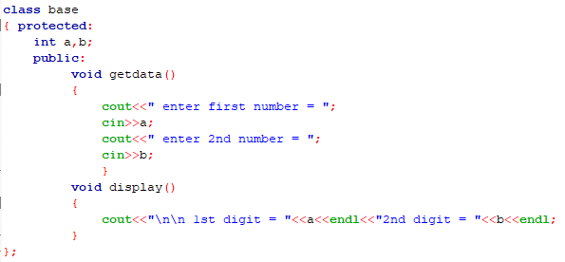

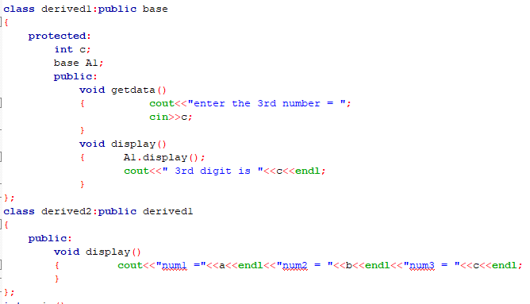

**Main:**

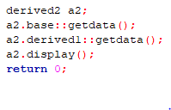

**Output:**

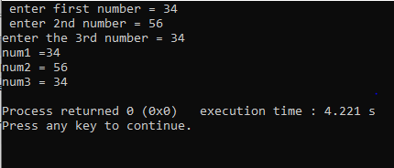

**5.2.**

**Classes:**

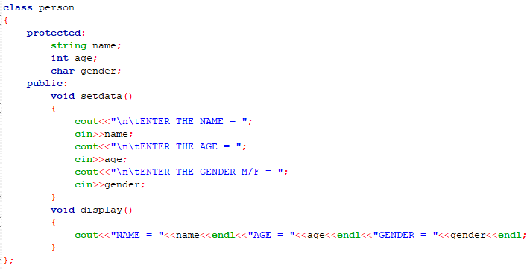

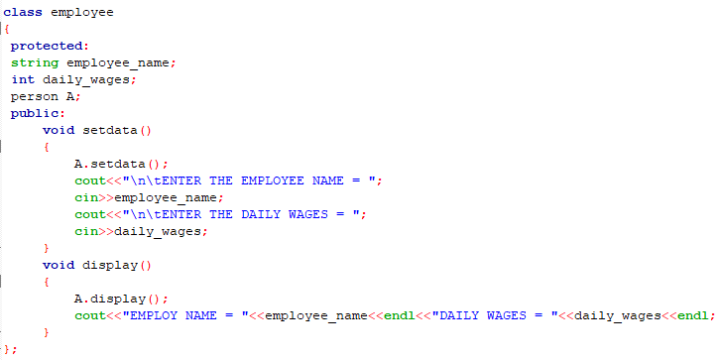

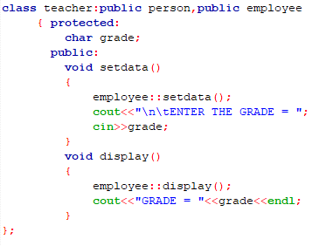

**Main:**



**Output:**

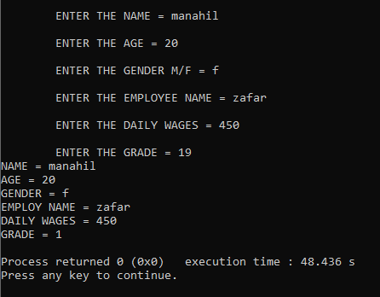

**5.3.**

**Classes:**

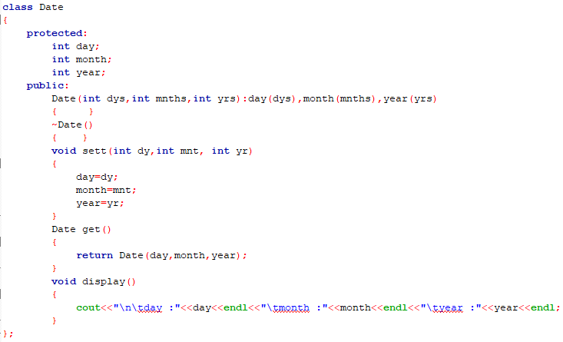

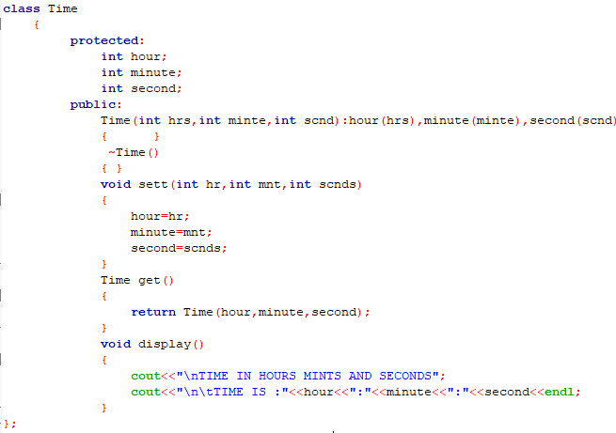

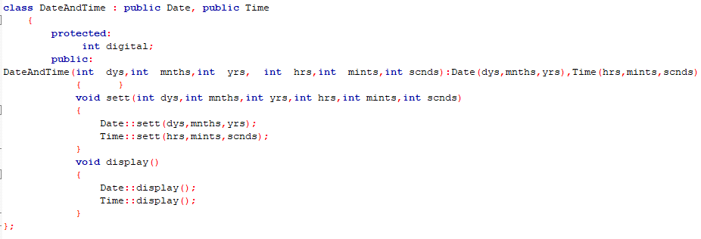

**Main:**

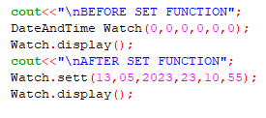

**Output:**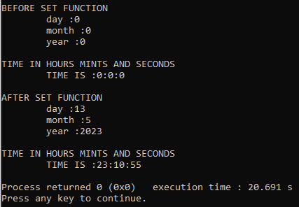

**5.4.**

**Classes:**

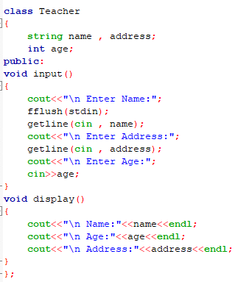

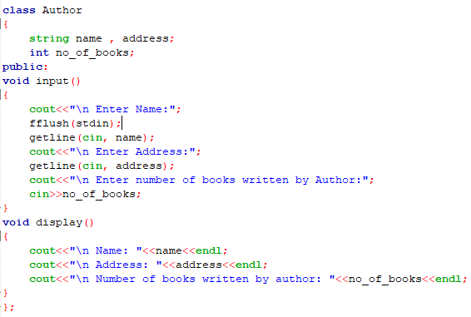

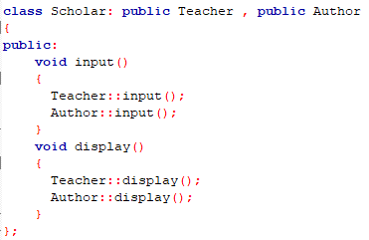

Main:

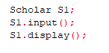

Output:

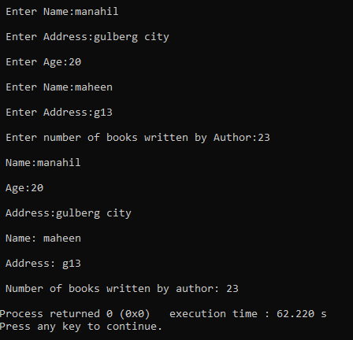

**Home Tasks**

**6.1**

Classes:

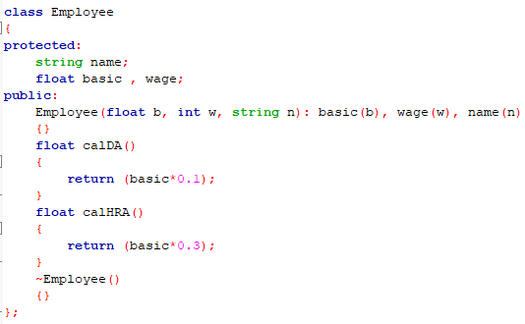

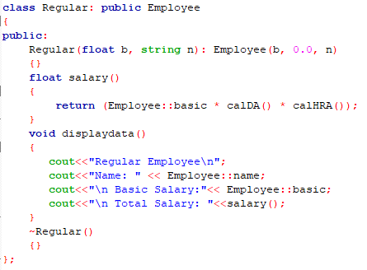

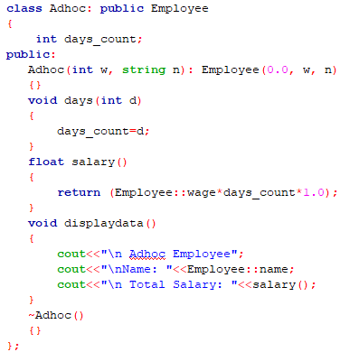

Main:

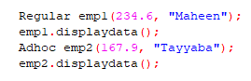

Output:

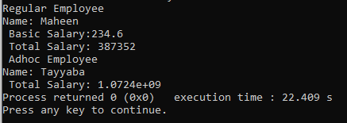

**6.2.** Write a program having a base class Student with data member *rollno* and member functions *getnum*() to input *rollno* and *putnum*() to display *rollno*. A class Test is derived from class Student with data member *marks* and member functions *getmarks*() to input *marks* and *putmarks*() to display *marks*. Class Sports is also derived from class Student with data member *score* and member functions *getscore*() to input *score* and *putscore*() to display *score*. The class Result is inherited from two base classes, class Test and class Sports with data member *total* and a member function *display*() to display *rollno*, *marks*, *score* and the *total*(*marks* + *score*).

**Program:**

**Classes:**

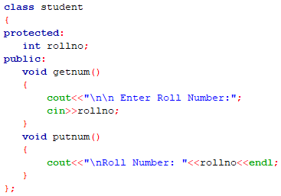

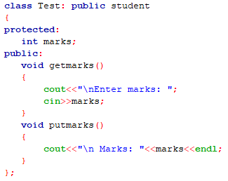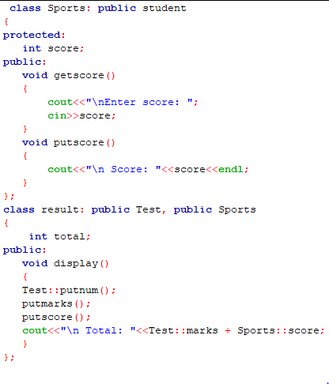

**Main:**

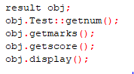

**Output:**

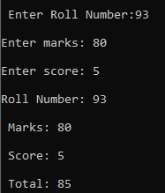

**6.3.** Write a class LocalPhone that contains an attribute *phone* to store a local telephone number. The class contains member functions to input and display phone number. Write a child class NatPhone for national phone numbers that inherits LocPhone class. It additionally contains an attribute to store *city code*. It also contains member functions to input and show the city code. Write another class IntPhone for international phone numbers that inherit NatPhone class. It additionally contains an attribute to store *country code*. It also contains member functions to input and show the country code. Test these classes from main() by creating objects of derived classes and testing functions in a way that clear concept of multi-level Inheritance.

Program:

Classes:

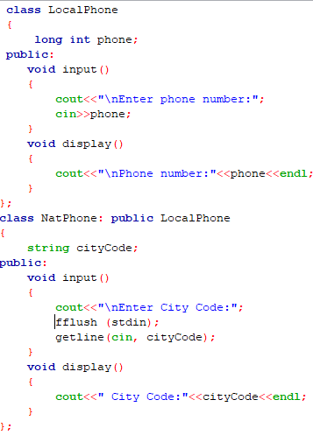

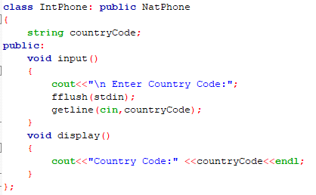

Main:

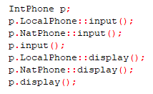

Output:

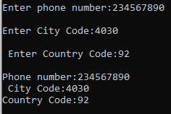

**6.4.** Start with the publication, book and tape classes. Add base class sales that holds an array of three floats so that it can record the dollar sales of a particular publication for the last three months. Include a getdata() function to get three sale amount from the user and a putdata() function to display the sales figure.

Alter the book and tape classes, so they are derived from both publication and sales.

An object of book or tape should should input and output ans sales data along with other data.

Write a main function to create a book and tape object and exercise their input/output capabilities.

Program:

Classes:

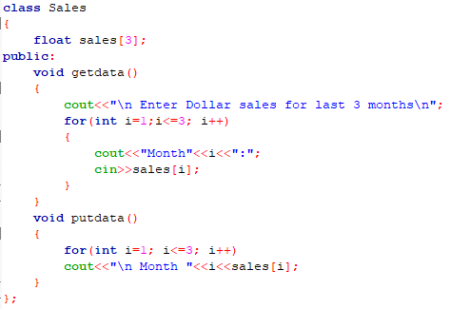

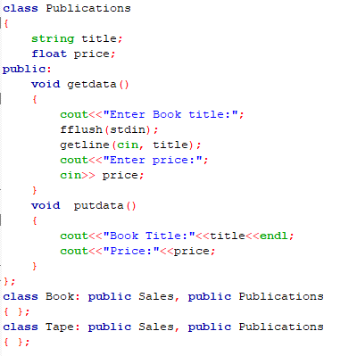

Main:

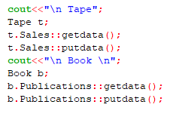

Output:

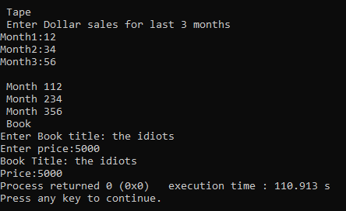

Critical analysis:

In this lab, we learn